Pacific County COVID-19 Status Report #80 July 8, 2020

Local Snapshot

Pacific County Positive Cases: 18

Pacific County Total Tests: 1058

All counties in WA State have reported confirmed cases of COVID-19, except Garfield County.

For the latest Washington State COVID-19 data please click on the link below:

https://www.doh.wa.gov/Emergencies/Coronavirus

For the latest PACIFIC COUNTY COVID-19 DATA please click on the link below. The page is very informative and illustrates how we are trying to disseminate information and resources:

https://www.pacificcountycovid19.com/

18th Positive COVID-19 Case Confirmed

We have received notice of an additional positive case of COVID-19 attributed to Pacific County. This positive case is in addition to the 17 previously reported cases for a total of 18 cases.

The individual with this positive case is incarcerated in a correctional facility and is currently out of Pacific County. This case is attributed to Pacific County because the individual’s permanent address is located in the county.

The Pacific County Health and Human Services Department will continue to investigate this most recent case and strongly encourages the public to maintain social distancing by limiting non-essential travel, and practice personal protective measures to include, washing hands often with soapy water for at least 20 seconds, avoid touching your face, and wearing a face covering in public. For up to date information and guidance about how to keep yourself and your family healthy, please visit: www.pacificcountycovid19.com.

__________________________________________________________________________________________

Statewide Snapshot

WA State Total Positive/Confirmed Cases as of 7/7/2020: 37,420. WA Total Deaths: 1,384

Neighboring Counties: Wahkiakum County 5 cases, Grays Harbor 32 cases, Lewis County 78 cases, Clatsop County 52 cases

__________________________________________________________________________________________

Inslee extends Safe Start proclamation, issues facial coverings guidance
Gov. Jay Inslee announced the extension of the Safe Start proclamation until August 6.
This extension clarifies the interaction between Safe Start and Department of Health Secretary John Wiesman's facial coverings order. It includes:
- The Yakima County business prohibition is extended statewide: No business may operate, allow a customer to enter a business, or conduct in-person business with a customer in any public setting unless the customer is wearing a face covering (as required, and with the exceptions outlined, in Order of the Secretary of Health 20-03;
- Individuals are prohibited from entering a place of business without wearing a face covering (again, per Order of the Secretary of Health 20-03); and
- Employers must notify the employer’s local health jurisdiction within 24 hours if the employer suspects COVID-19 is spreading in the employer’s workplace, or if the employer is aware of 2 or more employees who develop confirmed or suspected COVID-19 within a 14-day period.
The governor also announced additional clarification today for restaurant and taverns in Phases 2 and 3. This comes as more counties move forward under Washington’s Safe Start recovery plan.
Under this guidance, bar-style seating and live music are hereby prohibited in Phase 2 and Phase 3.
Additionally, restaurants and taverns in Phase 2 or beyond are now permitted to resume self-service buffets, salad bars, salsa bars, and other similar communal food sources and drink stations, subject to business adherence to safety standards.
Find the full memo here.
Find the full guidance here.
Full list of current reopening guidance.
_________________________________________________________________________________________

Why Should We Masks/Wear Face Coverings?

Video on Mask vs No Mask: https://www.kulr8.com/top_video/masks-put-to-the-test-do-they-help/video_90b8ffc0-baea-11ea-b6c8-6f758bb55221.html?utm_medium=social&utm_source=email&utm_campaign=user-share

Microdroplets: https://vimeo.com/402577241?ref=fb-share

WA State Providing Masks
The state purchased 3.6 million cloth face masks with a plan to distribute two masks to every person in Washington in a family who makes less than $52,400 per year.

- Willapa Behavioral Health
- Ocean Beach Hospital
- Willapa Harbor Hospital
- His Supper Table
- Ocean Park Food Bank
- South Bend Food Bank
- DSHS Offices
- WIC Offices
- CCAP Offices
**Pacific County Mask Makers: Facebook**

________________________________________________________________________________________

Washington Listens launches to support people affected by the stress of COVID-19
In response to COVID-19, Washington has launched Washington Listens, a support program and phone line to help people manage elevated levels of stress due to the pandemic.

People who call the Washington Listens support line will speak with a support specialist and get connected to community resources in their area. The program is anonymous.

“Washington Listens helps people cope and strengthen their resiliency in these uncertain times,” said Sue Birch, director of the Washington State Health Care Authority, the agency managing the program. “It complements the state’s behavioral health response services by providing an outlet for people who are not in crisis but need an outlet to manage stress.”

“This pandemic has had far-reaching effects that extend beyond our physical health. We are still in this fight against this virus, and this assistance will help Washingtonians recover during this uniquely stressful time,” said Mike O’Hare, FEMA Region 10 administrator.

The Washington Listens support line is 1-833-681-0211. It is available from 9 a.m. to 9 p.m. Monday through Friday, and 9 a.m. to 6 p.m. Saturdays and Sundays. TTY and language access services are available by using 7-1-1 or their preferred method.

Providers and tribes that have partnered with Washington Listens include American Indian Community Center, Colville Tribe, Community Integrated Health Services, Crisis Connections, Frontier Behavioral Health, Okanogan Behavioral Healthcare, and Swinomish Tribe.

The Washington Listens support line is made available by a $2.2 million Crisis Counseling Assistance and Training Program (CCP) grant funded by Federal Emergency Management Agency (FEMA) and supported by the Substance Abuse and Mental Health Services Administration (SAMHSA). This program supports short-term interventions to mitigate stress, promote the use or development of coping strategies, and provide emotional support to help Washingtonians understand and process their stress.

Resources and self-help tips are available on www.walistens.org
__________________________________________________________________________________________
COVID-19: More than a respiratory disease:

"We thought this was only a respiratory virus. Turns out, it goes after the pancreas. It goes after the heart. It goes after the liver, the brain, the kidney and other organs. We didn't appreciate that in the beginning,"
-Dr. Eric Topol, a cardiologist and director of the Scripps Research Translational Institute in La Jolla, California.

Source: https://www.reuters.com/article/us-health-coronavirus-effects/scientists-just-beginning-to-understand-the-many-health-problems-caused-by-covid-19-idUSKBN23X1BZ

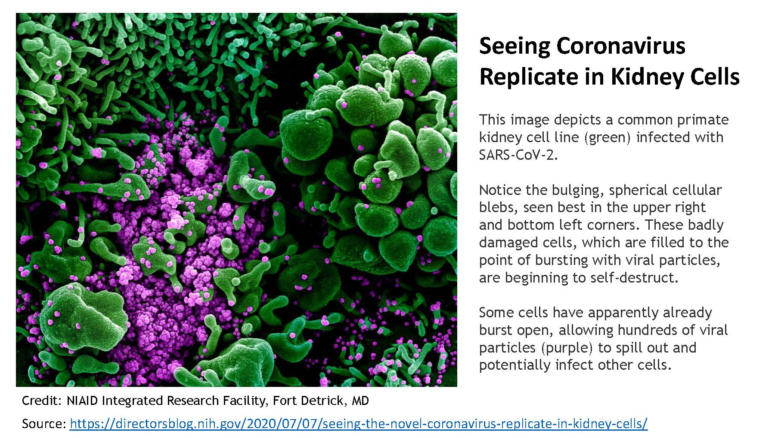____________________________________________________________________________________

Why Patient Location Information is Not Being Released
There has been a great deal written lately on social media centered on announcing where patients with positive Covid-19 test are located. For many years, all healthcare providers have been taught to use “Universal Precautions” to ensure they remain as healthy as possible. The assumption is that every patient is potentially infectious and it is up to the healthcare providers to protect themselves from being infected.

Every geographic area of Pacific County has been impacted by a positive Covid-19 test. It is imperative that Pacific County residents assume that everyone they meet is potentially infectious. It is equally imperative that residents realize that it is their personal responsibility to ensure they do not become infected. This is accomplished through limiting personal exposure and maintaining social distancing. Limiting non-essential travel. Using personal protective measures including, but not limited to, washing hands often with soapy water for at least 20 seconds, avoiding touching your face, and wearing a face covering.
Identifying where Covid-19 patients are located does nothing to protect anyone; in fact, it can create a false sense of security and do more harm than good.
__________________________________________________________________________________________

